Diaphragm study in ITU patients using ultrasound to decide when to wean from ventilator-:

Three vital organs in regard to achieving successful weaning-:

HLD –

* Heart- dysfunction lead to failure. 42 % weaning failure is due to hear failure.
  + Assisted PPV – leads to increased intrathoracic pressure (ITP_ and resultant fall in Ventricular return (VR) + Reduced left ventricular filling and decreased LV afterload- all this improved performance of hear.
  + On contrary- Unassisted breathing on MV leads to reduced IT and as result VTR increases, LV filling increases and LV after load increases- this results in poor LV function. This leads to Pulmonary edema (known as WIPO_ weaning induced pulmonary edema).
    - The ventricular contractability is assessed by just eyeballing. Look at contractability, change in muscle thickness with systole and asymmetrical contraction as well opening of valves.
    - In ITU, septic cardiomyopathy is significant issue – 40 -50 %.
    - This is easy way to decide need for ventricular support which can be done by ionotropic.
    - Also important to assess COP (cardiac output).
* Lung- pneumonia lead to weaning failure.
  + Decreased lung compliance -:
    - Pulmonary edema- can be diagnosed by USG even better then X ray- B lines are artefactual line which can help diagnosis pulmonary edema.
    - Below pulmonary edema.
    - 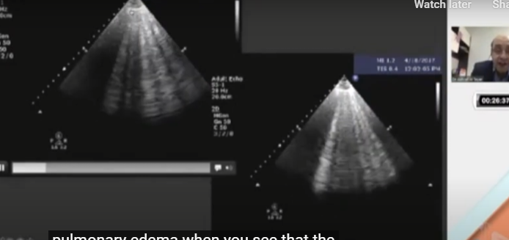
    - Below example of dry lung below-:
    - 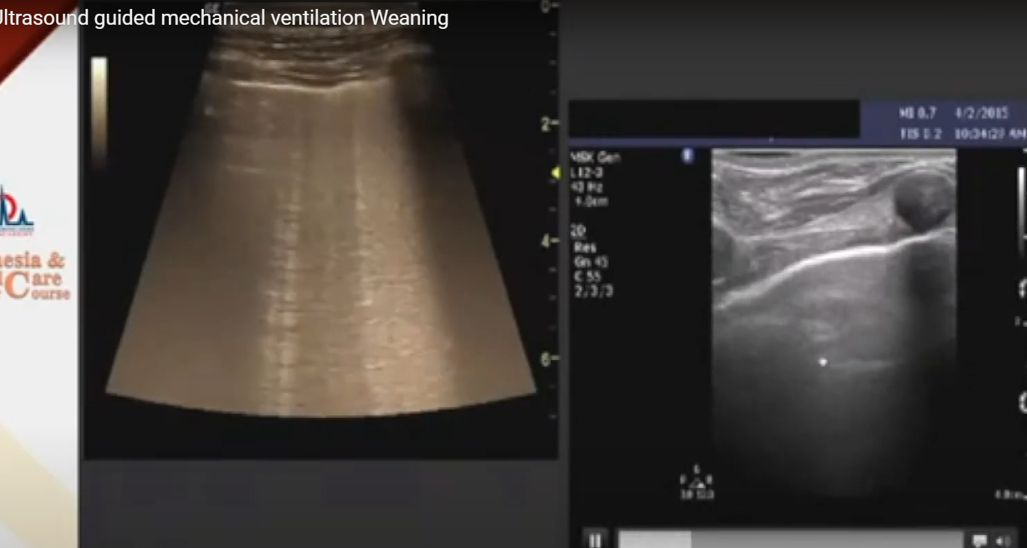
    - Finally below example of both – right B lines in pulmonary edema and left healthy dry lung with no B lines.
    - 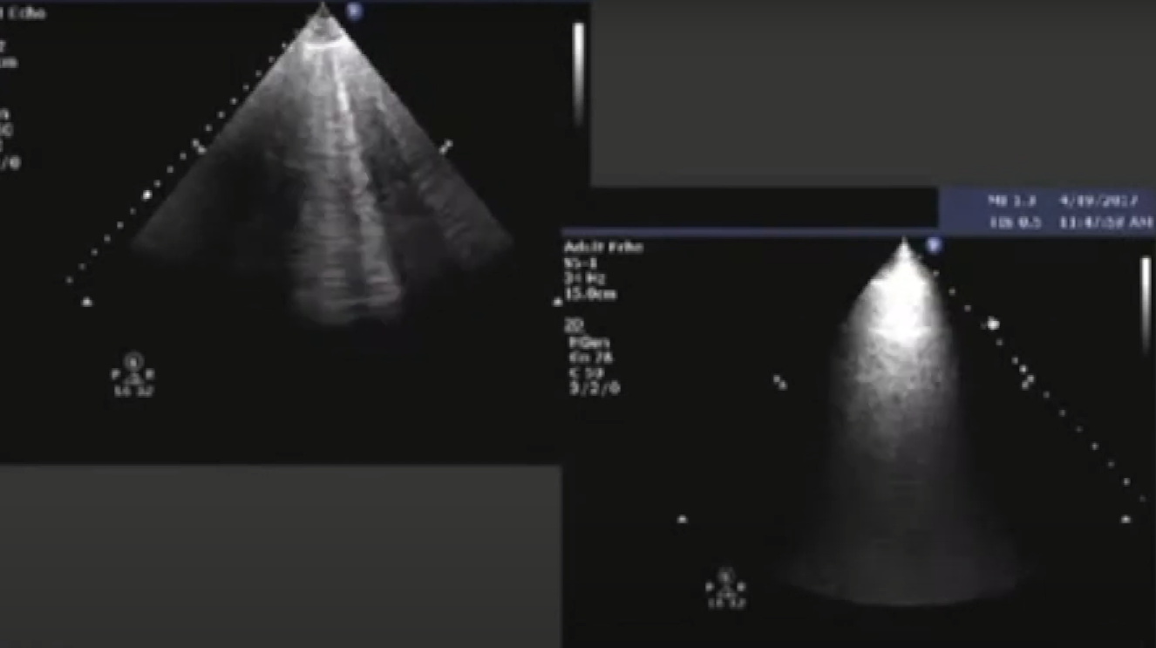
    - Recruited versus de-recruited lung = Lun aeration: Look for hepatisation of lung + dynamic air bronchogram v/static air bronchogram.
      * See link: <https://youtu.be/RoUkl12s6z4?t=1618>
      * The dynamic air bronchogram means white lines come and fade away – indicate consolidation and no collapse.
      * Static air bronchogram means white does or line stay and do not fade- indicate collapse and not just consolidation. (97% PPC for pneumonia).
      * If collapse is there then increase PPV to open the lung.
      * 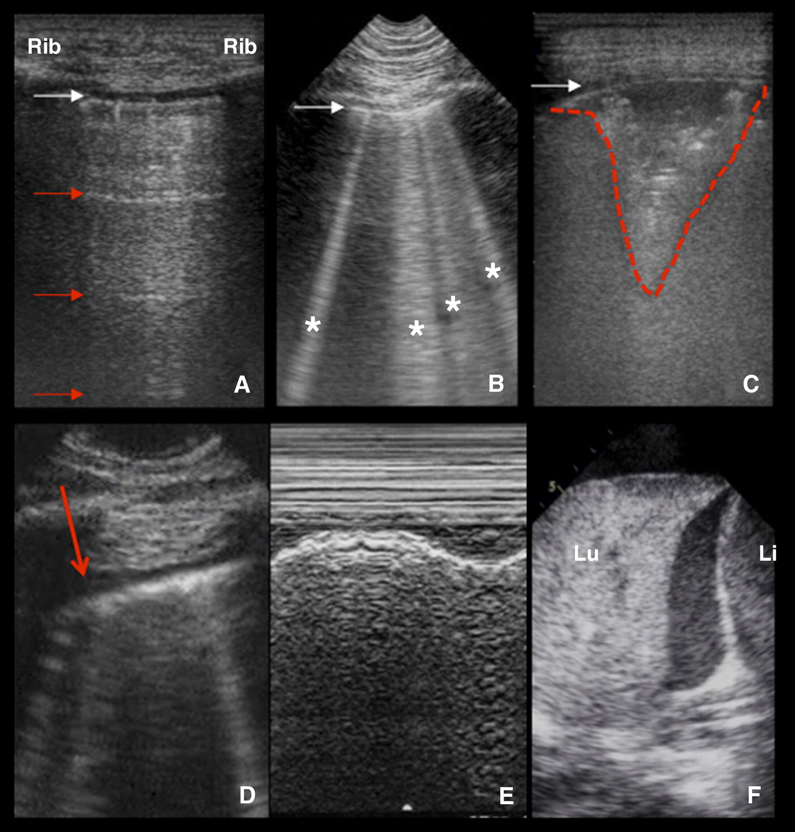Basic signs of lung ultrasound. (*A*) The pleural line (white arrow) is identified between the ribs (bat sign); horizontal reverberation artifacts (A-lines, red arrow) at a regular distance indicate a high gas–volume ratio below the parietal pleura (longitudinal scan, linear probe). (*B*) B-lines (asterisks) are vertical artifacts deriving from the pleural line, moving synchronously with lung sliding, usually hyperechoic and laser shaped, usually reaching the bottom of the screen and erasing A-lines (white arrow, pleural line; longitudinal scan, microconvex probe). (*C*) Subpleural consolidation (dashed red line): an echo-poor image juxtaposed to the pleural line (white arrow) and delimited by irregular boundaries, the “shred sign” (transversal scan, linear probe). (*D*) A very small pleural effusion is visualized as a hypoechoic space between the parietal and visceral pleura (red arrow; longitudinal scan, microconvex probe). (*E*) M-mode of the same scan confirms the presence of the pleural effusion, showing the lung freely floating in it (“sinusoid sign”). (*F*) Tissue-like pattern identifies lobar consolidation, surrounded by pleural effusion (Li = liver; Lu = lung; longitudinal scan, phased-array probe
      * 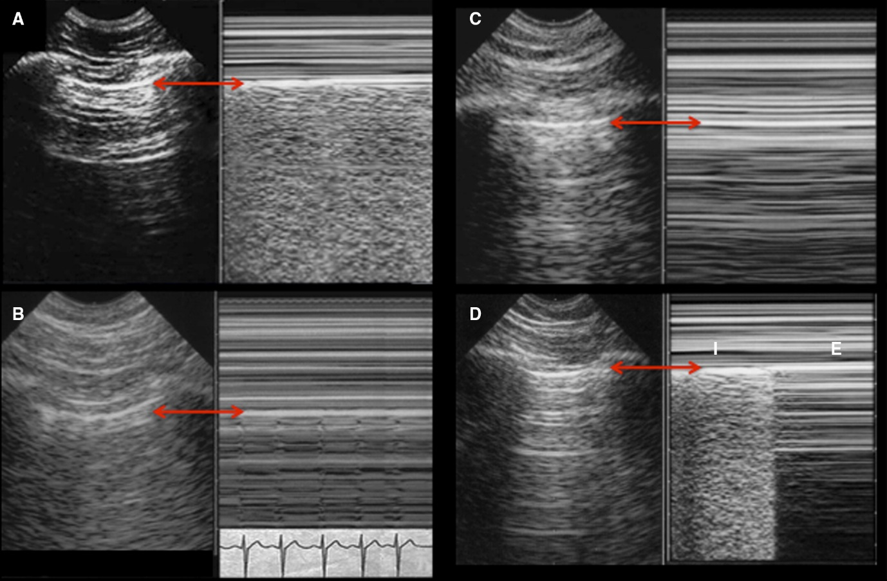Basic signs of lung ultrasound in M-mode with corresponding two-dimensional images in longitudinal scan with microconvex probe; red arrows indicate the pleural line. (*A*) M-mode demonstrates normal sliding: above the pleural line; superficial tissues do not move away or toward the probe and are represented as straight lines. The pattern below the pleura is an artifact deriving from it: if the visceral pleura slides, it generates a sandy pattern (“seashore sign”). (*B*) If the visceral pleura does not slide but only beats synchronously with the heart, a different M-mode pattern is visualized (lung pulse). (*C*) A pneumothorax is suspected when no lung sliding is visualized, as confirmed by straight lines both above and below the pleural line (“stratosphere sign”). (*D*) Pneumothorax is confirmed by the presence of the lung point, visualized in M-mode as the alternation of “seashore” and “stratosphere” signs, at the location where the collapsed lung comes in touch with the parietal pleura during inspiration (E = expiration; I = inspiration).
      * (*A*–*C*) Lobar consolidations are visualized as a tissue-like pattern; the air bronchograms are visualized as hyperechoic signs within consolidation and provide additional information on consolidation etiology. (*A*) The consolidated lung is visualized in transversal scan. It is homogeneously gray: air bronchogram is absent, which means airway is not clearly patent. Disobstructive fiber bronchoscopy may be indicated; no final conclusions on consolidation etiology can be drawn. (*B*) Multiple white spots (red arrows) are visualized within the consolidated lung in transversal scan and move synchronously with tidal ventilation: dynamic air bronchogram rules out obstructive atelectasis. (*C*) A dynamic linear/arborescent air bronchogram is specific for community-acquired and ventilator-associated pneumonia (longitudinal scan; dashed red line, diaphragm; L = lung; S = spleen). (*D*–*F*) Ultrasound features of pleural effusions. (*D*) Pleural effusion is here visualized in transversal scan as an anechoic space between the lung (on the right) and the posterior wall of the chest (on the left); transversal scan allows the measurement of the maximal interpleural distance (red arrow) and the quantification of the fluid collection, providing information about adequacy of chest drainage. Its homogeneous anechoic pattern orients to transudate; the lung appears partially consolidated. (*E*) Septa and adherences are visualized within the pleural effusion in transversal scan: a phlogistic etiology is suggested, and septa discourage percutaneous chest drainage. (*F*) A massive echoic pleural effusion is visualized in transversal scan between a collapsed lung (on the right) and the posterior wall of the chest (on the left); the nonhomogeneous pattern orients to exudate or blood (depending on clinical context); Chest drainage is indicated.
      * 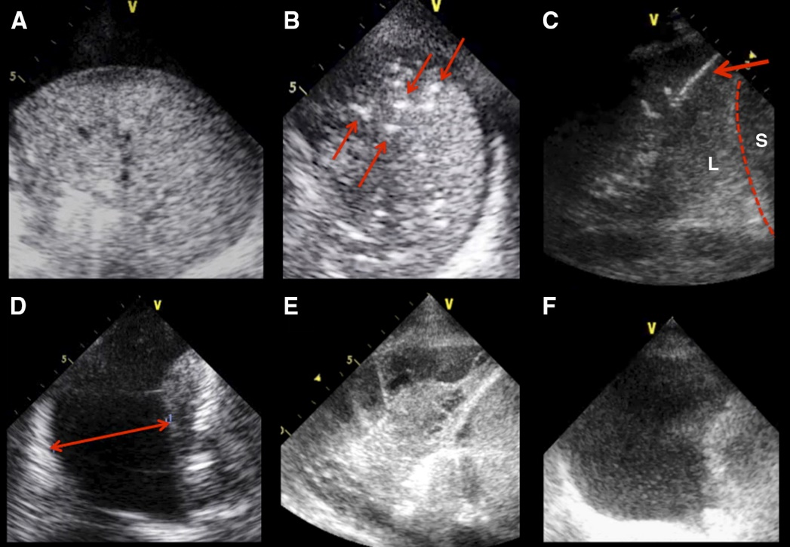
  + Decreased chest wall compliance.
* Diaphragm- muscle weakness will lead to weaning failure (best treatment for diaphragmatic weakness is diaphragm training).
  + Provides 80% inspiratory effort
  + 40-50% of diaphragmatic function will be loss once patient is on mechanical ventilation. (disuse atrophy).
  + Best way to monitor diaphragm is ultrasound (even between then fluoroscopy !)
    - Three parts of diaphragm- visceral (towards lung) / parietal (towards liver) and intercrural.
    - Thickness fraction- calculate with linear probe at ZOA (zone of apposition)- : thickness during inspiration – thickness during expiration / thickness in expiration= thickness fraction. Can measure in M mode or in B mode by freezing images in inspiration and expiration and measuring the actual thickness of diaphragm. Thickness will increase during contraction (inhalation)= thickness increases more then 30 % at least to predict successful weaning.

**Diaphragmatic excursion**- needs convex low frequency probe- Probe subhepatic or sub splenic- Directed cranially, medially, and dorsally. Located either in mid clavicular or anterior axillary line. Use B mode and M mode. Diaphragm moves caudally with inspiration and cranially with expiration.

* + - * Examine during quiet breathing/deep breathing. Sniff test.
      * Excursion should be above 2 to predict successful weaning.
      * Excursion velocity should be < 1.3 cm/sec indicate strong diaphragm.
      * Paralyses- there is flare in m mode. 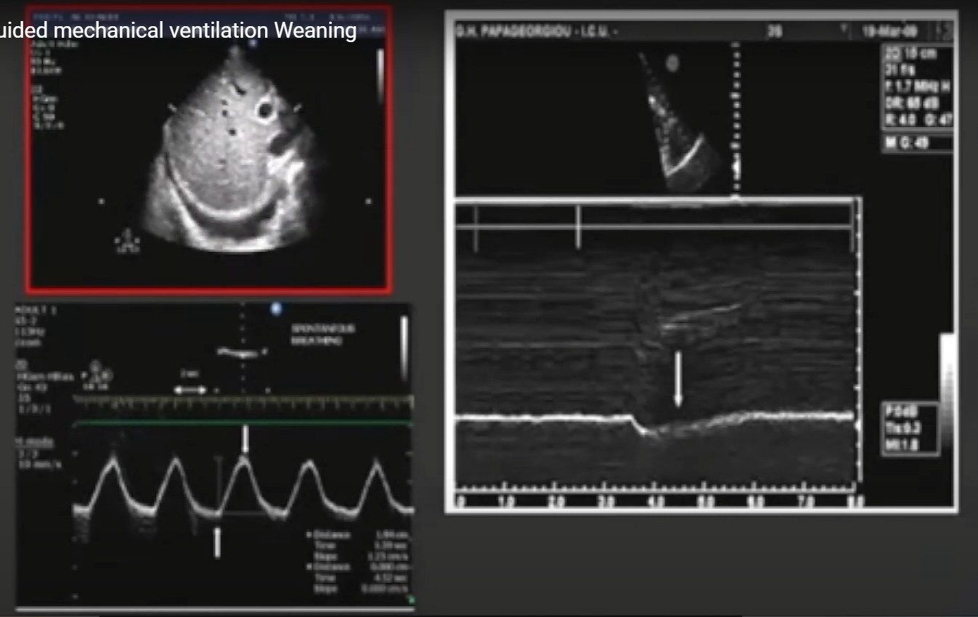
      * Dipahragm-centilator synchrony : 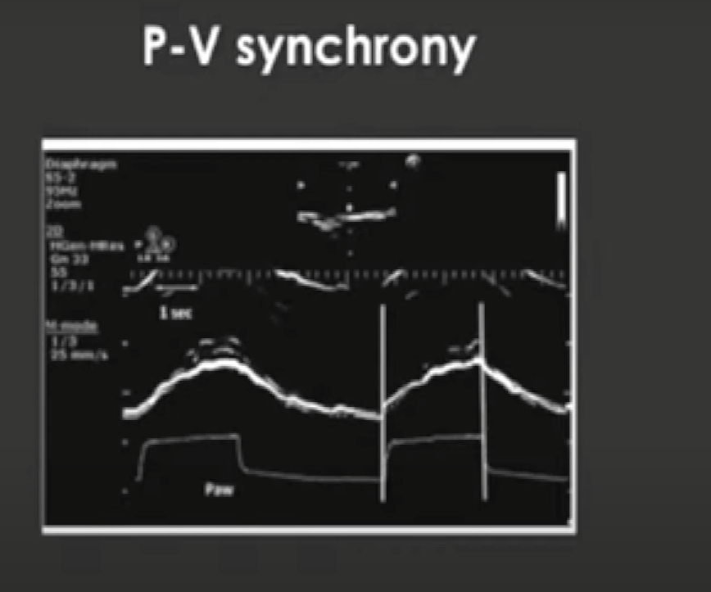

Normal values:

Diaphragmatic excursion:

|  |  |  |  |
| --- | --- | --- | --- |
|  | Female | Male | Comment |
| Quiet breathing | 9 mm | 10 mm | Some people say remember the value od 2 cm. |
| Deep breathing | 37 mm | 47 mm | Better seen on right then left |
| Sniffing | 16 mm | 18 mm | Better seen on right then left |

In general, the excursion is more in male then females (b5 up to 3mm). Underweight people have LESS excursion (by 10mm) then normal or obese patients. Younger patient < 30 years has less excursion (by 5mm) then the older patients.

Diaphragmatic thickness:

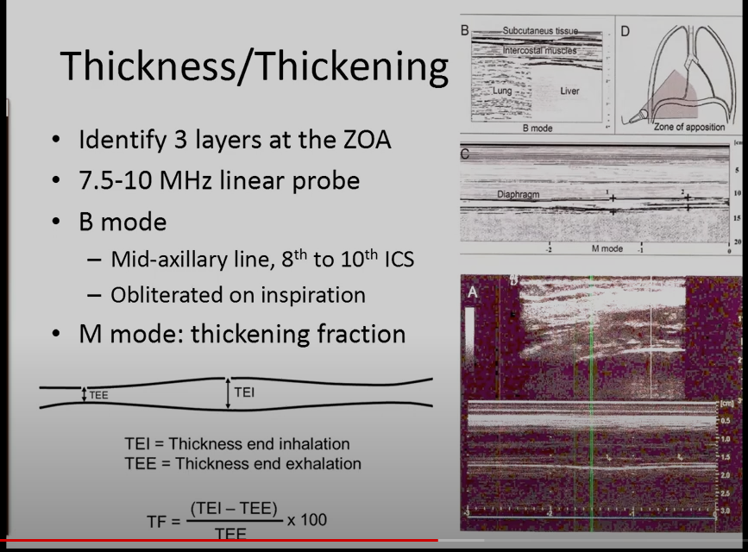

Thickness fraction:

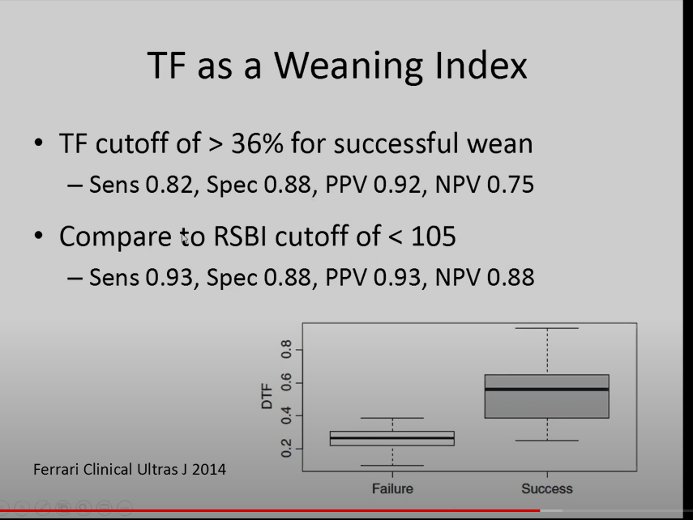

Speckle tracking:

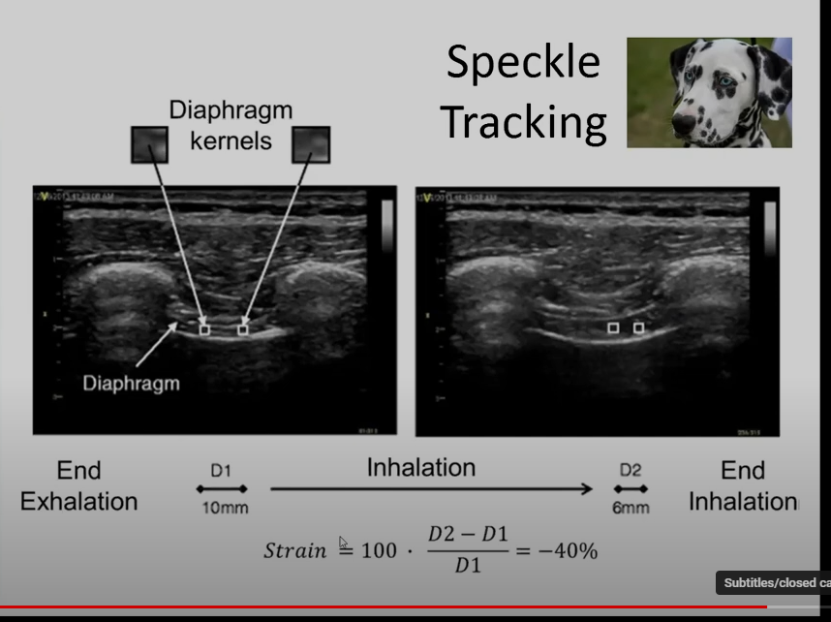

Intercostal muscle-:

Assess the change in width of the intercostal muscles in parasternal location.

Take home:

